**COMP 488 – Rapid APP using .NET**

**Professor:** Karim Kabani

**Project Update**

**Project Name**: Chicago Crime Alert Application

**Members**: Carla Robinson, Jack Broncato, Vismark Juarez

**Project Abstract**: The objective of this application is to inform users of criminal activities occurring within areas they may be interested. The Chicago Crime Alert Application will enable users to sign up for SMS text notifications of criminal activity reported within specific Chicago wards. This will allow users a high level of awareness as to what sort of criminal activity (if any) is occurring within a ward/neighborhood specified. Additionally, users of this application will also be able to search for historical crime trends that have occurred within Chicago wards or neighborhoods of interest. The statistics available to users will include metrics on the types of crimes that have been committed in certain wards and years in Chicago, as well as the frequency with which they occur.

**Features Completed**:

* SMS sign-up UI and SMS text messaging capabilities
* Cloud Database connectivity
* UI navigation control (switching screens)
* Fetching data from the Crime Portal API
* Displaying charts with up-to-date data in the ‘Crime Statistics’ Page

**Features to be completed**:

* Creating the back-end logic for sending users daily text alerts.
* Populating information on the ‘Crime Related News’ and ‘About Us’ sections.
* Perform final polishing of the UI, adding graphs to WPF version if possible.

**Issues if any:** No issues have been encountered thus far.

**Project Plan (Schedule/Timeline):**

* 11/22: UI and all relevant pages should be fully implemented.
* 11/29: All back-end logic should be finalized (including the daily sms text messaging capabilities)
* 12/3: All final refactoring work should be done.

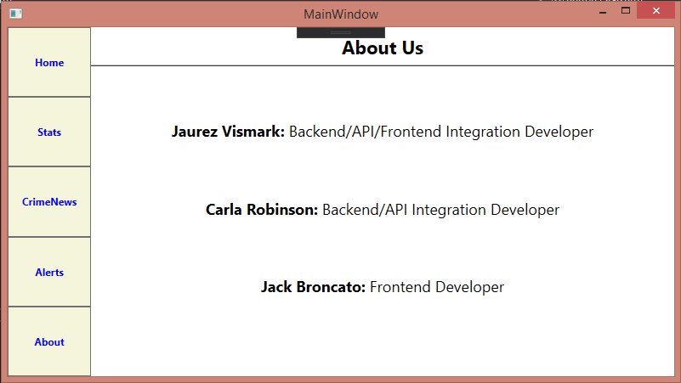**>>

**Database Diagram**: <<>>

**Couple of lines from each group member on what they have worked on; the entire group have to agree with each other on the work split**: <<

Jack Broncato: Improved WPF frontend, Charts are needed but otherwise it is in good condition.

>>